The PowerHouse

South Fremantle Power Station Redevelopment
Presentation-ready concept and planning proposal
A mixed-use destination combining industrial heritage, culture, public life, sustainable power, technology research, biosciences, education, hospitality and coastal recreation.
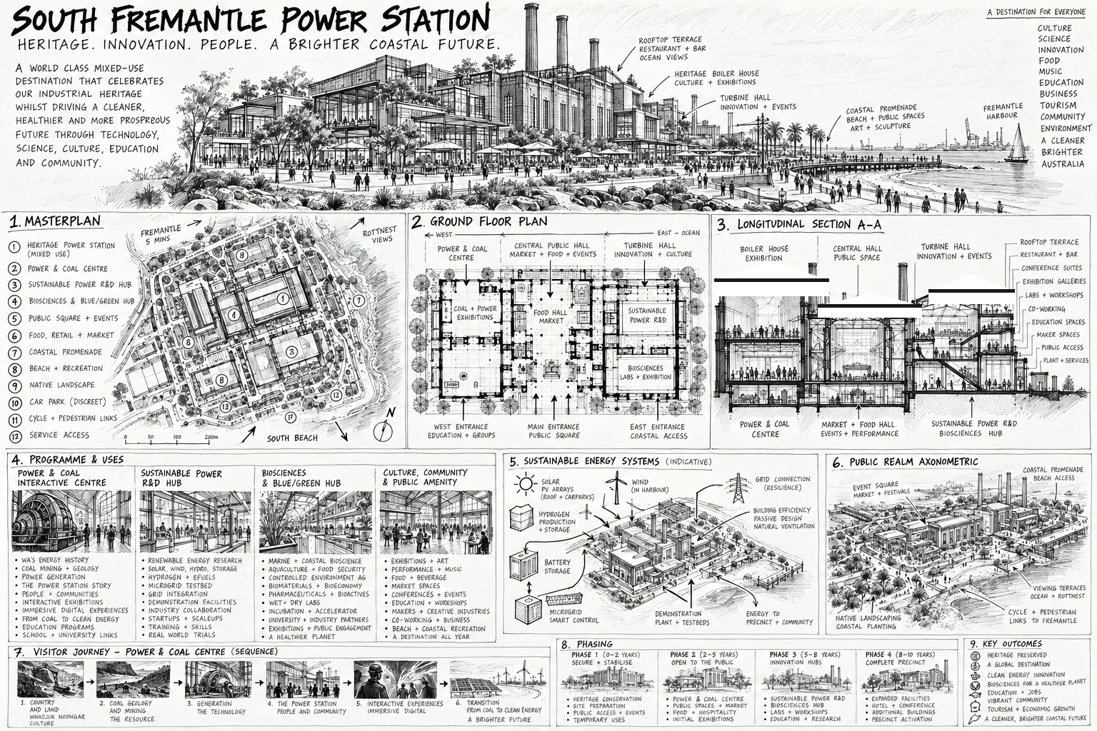

1. Executive Summary
The PowerHouse is proposed as a world-class mixed-use destination built around the adaptive reuse of the South Fremantle Power Station. The project preserves the monumental industrial character of the former power station while giving it a new civic and economic purpose.
The central proposition is simple: transform a monument to the industrial past into a working institution for the future. The PowerHouse would combine heritage interpretation, contemporary culture, food and hospitality, public space, education, sustainable-energy research and development, biosciences, entrepreneurship and technology commercialisation.
The proposal draws strategic lessons from Manufaktura in Łódź, Battersea Power Station, BALTIC in Gateshead and The Glasshouse/Sage in Newcastle upon Tyne. Each precedent demonstrates a different component of successful regeneration: industrial heritage as an asset; mixed-use activation; culture as a destination driver; public realm; education; events; and environmental innovation.
The South Fremantle opportunity is distinctive because it can combine these qualities with a major public-facing energy-transition and bioscience innovation campus within an authentic historic power station and a coastal public realm.

The proposition
- A living heritage destination rather than a static museum.
- A major public Power & Coal Interactive Centre telling the story of energy from coal to the clean-energy transition.
- A Sustainable Power Innovation Hub for research, prototyping, demonstration and commercialisation.
- A Bioscience & Blue-Green Innovation Hub focused on marine, agricultural, environmental and life-science opportunities.
- A cultural destination for art, music, exhibitions, performance, festivals and conferences.
- A food, market and hospitality destination operating throughout the day and evening.
- A major public square, landscape and coastal promenade connecting the Power Station to its surrounding community and coast.
- A living laboratory in which the building itself demonstrates renewable power, storage, water, energy efficiency and smart systems.

2. Vision
The PowerHouse should become a destination where people can experience the history of energy, encounter the science of the future, see new technologies being developed, eat, work, learn, perform, exhibit, meet and relax.

The central narrative
COAL → POWER → INDUSTRY → ELECTRICITY → CLIMATE → TRANSITION → INNOVATION → FUTURE ENERGY
The historic power station converted coal into energy. The new PowerHouse should convert ideas into science, technology, companies, jobs and public benefit.

Four anchors
Anchor | Purpose
Power & Coal Centre | Industrial history, energy education and interactive visitor experience.
Sustainable Power Innovation Hub | Energy research, demonstration, start-ups and commercialisation.
Bioscience & Blue-Green Hub | Marine, agricultural, environmental, food and life-science innovation.
Culture, Food & Public Realm | Art, music, events, markets, hospitality, recreation and community life.

3. Precedent Lessons

Manufaktura — Łódź
The key lesson is to make the industrial complex a complete destination rather than a collection of heritage buildings. A strong public square, food, culture, retail, events and everyday activity create a place that remains busy beyond visitor hours.
Application to South Fremantle: PowerHouse Square should be the social heart, surrounded by food, markets, culture, innovation and public events.

Battersea Power Station — London
The key lesson is the capacity of a major power station to become the identity and organising element of a large mixed-use regeneration project. Heritage, commerce, culture, hospitality and public life can reinforce one another.
Application to South Fremantle: retain the Power Station as the unmistakable icon while using complementary development and public realm to support its long-term operation.

BALTIC — Gateshead
The key lesson is adaptive reuse at cultural scale: the industrial volume itself becomes the attraction, while galleries, performance, education, hospitality and public circulation occupy the existing structure.
Application to South Fremantle: keep the major industrial volumes legible and use lightweight, reversible contemporary insertions.

The Sage / Glasshouse — Newcastle
The key lesson is the integration of culture, education, performance, public realm, hospitality and environmental thinking into one destination.
Application to South Fremantle: combine cultural programming with education, science, business and a low-carbon operating model.

The South Fremantle difference
The proposal should not reproduce any precedent. Its distinctive proposition is the combination of industrial heritage, coastal public space, energy-transition research, biosciences and culture in one working destination.

4. Masterplan
The masterplan should be organised around the retained Power Station, a new public forecourt and square, a network of landscaped pedestrian routes, coastal connections and a series of complementary new or adapted spaces.

Indicative site structure
- Retained Power Station and principal heritage volumes.
- Power & Coal Interactive Centre.
- Sustainable Power Innovation Hub.
- Bioscience & Blue-Green Innovation Hub.
- PowerHouse Square and event lawn.
- Food, market, hospitality and retail edge.
- Coastal promenade and public access.
- Native landscape and science gardens.
- Cycle and pedestrian network.
- Discrete parking and service areas.
- Separate service access to protect public spaces.

Planning principles
- Retain the icon.
- Make the heritage structure publicly accessible.
- Keep major volumes visually legible.
- Use contemporary interventions that are clearly differentiated from historic fabric.
- Create a strong public heart.
- Connect the site physically and visually to the coast.
- Programme the site for morning, afternoon and evening use.
- Separate service and visitor movements wherever practicable.
- Use landscape to soften new interventions and establish a strong local identity.
- Make sustainability visible rather than hidden in plant rooms.

5. The Power & Coal Interactive Centre
This should be one of the signature visitor attractions. It should explain energy as a human, industrial, scientific and environmental story rather than treating coal simply as a historical artefact.

Visitor journey
- Country and geology.
- Coal formation and resources.
- Mining and transportation.
- Industrialisation.
- Generation of electricity.
- The South Fremantle Power Station.
- The electricity grid and modern life.
- Climate and the changing energy system.
- Renewable energy and storage.
- Hydrogen and emerging technologies.
- The future of energy.

Experience
- Immersive projection and sound.
- Interactive models of boilers, turbines, generators and grids.
- Augmented and digital interpretation.
- Historic machinery and industrial artefacts.
- Real-time energy dashboards.
- School and university programmes.
- Public demonstrations.
- Temporary exhibitions linking historical energy systems to contemporary technology.

6. Sustainable Power Innovation Hub
The PowerHouse should not merely talk about the energy transition. It should house organisations researching, testing and commercialising technologies that enable it.

Potential research and demonstration themes
- Solar energy and next-generation photovoltaics.
- Battery and long-duration energy storage.
- Hydrogen and renewable fuels, subject to safety, economics and approvals.
- Smart grids and microgrids.
- Energy management and demand response.
- Industrial electrification.
- Energy efficiency and building systems.
- Marine and coastal energy technologies.
- Water-energy systems.
- Carbon reduction and circular-economy technologies.
- Energy systems for remote and regional communities.

The innovation pipeline
RESEARCH → PROTOTYPE → DEMONSTRATE → INVEST → COMMERCIALISE → EXPORT
The Hub should bring together universities, researchers, entrepreneurs, corporate partners, investors and government agencies. It should provide laboratories, prototyping, demonstration space, incubator and accelerator programmes, meeting facilities and investor access.

The building as a living laboratory
- Roof and new-structure solar generation where appropriate.
- Battery storage demonstration.
- Site microgrid and smart energy management.
- Energy monitoring visible to visitors.
- Water harvesting and reuse.
- Passive design, shading and natural ventilation where compatible with heritage requirements.
- High-performance new construction.
- Waste and resource recovery systems.
- Research and demonstration areas integrated into the public visitor journey.

7. Bioscience & Blue-Green Innovation Hub
The Bioscience Hub would provide a second innovation pillar, drawing on Western Australia's strengths in marine science, agriculture, biotechnology, food systems and environmental science.

Potential fields
- Marine biotechnology and aquaculture.
- Algae, blue carbon and ocean health.
- Marine-derived pharmaceuticals and biotechnology.
- Sustainable seafood and food systems.
- Plant science and crop resilience.
- Biological fertilisers and biological pest management.
- Antimicrobial technologies.
- Soil and environmental health.
- Diagnostics, biotechnology and life sciences.
- Biosimilars and advanced biological manufacturing.
- Fermentation and alternative proteins.
- Environmental remediation and ecological restoration.

Visible science
Where technically and commercially appropriate, laboratories should be visible from public circulation routes. Science should be presented as something happening now, with researchers, founders and students working within the destination.

8. Culture, Performance & Events

The Great Boiler Hall
Retain the exceptional volume and structural expression. The Boiler Hall can become a flexible hall for major exhibitions, science installations, conferences, large dinners, festivals, product launches and public events.

The Turbine Hall
The Turbine Hall becomes a principal cultural and event space for exhibitions, markets, music, performance, lectures, technology demonstrations and evening events.

Performance
- Flexible main performance hall.
- Black-box experimental venue.
- Music academy and teaching rooms.
- Recording, broadcast and digital production studios.
- Outdoor performance capability.

Art + Science + Technology
A defining programming strand should commission collaborations between artists, scientists, engineers, designers and technologists. This creates content that is unique to the PowerHouse rather than replicating conventional museum or gallery programming.

9. PowerHouse Market & Hospitality
A daily destination needs a strong economic and social heart. PowerHouse Square should be framed by food, market and hospitality uses.
- Food hall.
- Local produce and farmers' markets.
- Restaurants and cafés.
- Bars and evening dining.
- Artisan and design businesses.
- Local maker retail.
- Temporary markets and festivals.
- Outdoor dining.
- Public events and seasonal programming.
The aim is to create a place that is useful even when a visitor has no particular interest in heritage or science.

10. Education & Public Science
Education should run through the whole PowerHouse rather than being confined to a single classroom wing.
- Primary and secondary school programmes.
- University research and teaching partnerships.
- STEM education.
- Energy and climate programmes.
- Biology and marine science programmes.
- Apprenticeships and technical skills.
- Internships and work experience.
- Public lectures and science cafés.
- Entrepreneurship and commercialisation programmes.

Science Street
A publicly accessible internal route can connect visible laboratories, technology demonstrations, start-ups, workshops, lecture rooms and exhibition spaces, allowing visitors to see innovation taking place.

11. Public Realm & Coastal Connection
The Power Station should not terminate at its walls. The landscape is part of the destination.
- PowerHouse Square.
- Landscaped public forecourt.
- Coastal promenade.
- Cycle and pedestrian connections.
- Outdoor amphitheatre.
- Science Garden.
- Energy Garden.
- Native coastal planting.
- Children's play and discovery spaces.
- Outdoor art and sculpture.
- Beach and coastal recreation connections.
The public realm should provide a continuous sequence from neighbourhood arrival through the industrial building and out to the coast.

12. Rooftop & Outlook
Subject to heritage, structural, planning and aviation considerations, selected roof areas could provide a distinctive public outlook.
- Restaurant and bar.
- Observation terrace.
- Rooftop garden.
- Event terrace.
- Solar demonstration.
- Views towards the coast, Fremantle and Rottnest.

13. Indicative Programme
Zone | Principal uses
Power & Coal Centre | Industrial history, interactive energy museum, visitor experience.
Great Boiler Hall | Major exhibitions, events, conferences, installations.
Turbine Hall | Performance, culture, markets, technology and events.
Sustainable Power Hub | Energy R&D, laboratories, demonstration and commercialisation.
Bioscience Hub | Biotechnology, marine, agricultural, food and environmental science.
Innovation Quarter | Start-ups, incubator, accelerator, co-working, investors.
PowerHouse Market | Food, hospitality, local produce, retail and markets.
Culture Quarter | Art, digital media, exhibitions, studios and education.
Music Academy | Teaching, recording, performance and digital production.
Conference Centre | Business, science and international events.
Science Street | Public-facing laboratories and innovation.
PowerHouse Square | Markets, festivals, gatherings and public life.
Coastal Park | Landscape, recreation, public art and outdoor events.
Rooftop | Hospitality, viewing and events.

14. Sustainability Strategy
Sustainability should be both an operational objective and a visitor experience.

Energy
- Renewable generation integrated where appropriate.
- Battery and other storage technologies.
- Microgrid and smart controls.
- Energy-efficient building services.
- Real-time energy monitoring.

Water
- Rainwater capture.
- Water-efficient planting.
- Greywater or treated-water reuse where viable.
- Water-sensitive urban design.

Materials & Heritage
- Maximum practical retention of existing fabric.
- Adaptive reuse before demolition.
- Reversible or lightweight internal interventions.
- Low-carbon materials in new construction.
- Circular procurement and reuse.

Landscape
- Native and climate-resilient planting.
- Coastal ecology.
- Shade and urban cooling.
- Biodiversity enhancement.
- Water-sensitive landscapes.

15. Development & Phasing
Phase | Indicative timing | Principal outcomes
0 — Secure & Understand | 0–2 years | Heritage, structural, contamination, services, environmental, transport and business-case investigations.
1 — Open the Power Station | 2–4 years | Visitor centre, Power & Coal Centre, PowerHouse Square, initial food, events and public realm.
2 — Culture & Events | 3–6 years | Turbine Hall, exhibitions, performance, music, conference, markets and expanded hospitality.
3 — Science & Technology | 4–8 years | Sustainable Power Hub, Bioscience Hub, laboratories, incubator, university partnerships and demonstrations.
4 — Destination Completion | 6–10 years | Expanded hospitality, rooftop, further innovation space, coastal activation and mature events programme.

16. Economic & Operating Model
The project should have multiple complementary revenue streams so that public benefit is supported by a resilient operating model.
- Food, beverage and hospitality.
- Retail and markets.
- Venue and event hire.
- Exhibitions and ticketed experiences.
- Conference and corporate events.
- Laboratory and innovation-space leases.
- Research partnerships.
- Corporate innovation programmes.
- Education and professional training.
- Tourism and visitor experiences.
- Technology incubation and commercialisation.
- Public and philanthropic support for cultural and educational functions.
The financial model should distinguish heritage/public-good functions from commercially leasable activities while allowing the overall destination to cross-support itself.

17. Governance
A dedicated South Fremantle PowerHouse governance and development vehicle should be considered, with appropriate representation from government, heritage, community, Indigenous interests, universities, science, business, investment and culture.
Operationally, the project can be structured around specialist functions—Heritage & Culture, Science & Technology, Commercial Property, and Hospitality & Events—under one destination strategy.

18. Visitor Journey
Time | Experience
10:00 | Coffee, coastal outlook and arrival.
10:30 | Power & Coal Centre.
12:00 | Science and technology exhibition.
13:00 | PowerHouse Market and food hall.
14:00 | Bioscience discovery and Science Street.
15:00 | Coastal walk, landscape and public art.
16:00 | Contemporary art and digital installation.
17:30 | Rooftop or waterfront hospitality.
18:30 | Market, festival or public event.
20:00 | Music or performance.
22:00 | Dinner and evening destination.
The objective is all-day and evening activation: the visitor should be able to spend a full day at the PowerHouse without exhausting the offer.

19. Design Language
The architectural presentation and design development should use a monochrome, hand-drawn language inspired by the graphic character of a-ha's Take On Me video: black ink, graphite, cross-hatching, expressive perspective, hand-written annotation and diagrammatic architectural drawing.
This is not intended as a literal imitation of the video. The design language should capture the feeling of architectural ideas being drawn into existence: historic industrial structure rendered with hand-drawn authority, contemporary insertions clearly differentiated, and future technologies emerging from the old building.
- Black and white presentation boards.
- Hand-drawn masterplans.
- Sectional perspectives.
- Exploded axonometrics.
- Programme diagrams.
- Energy-flow diagrams.
- Visitor-journey drawings.
- Phasing sketches.
- Expressive people and activity.
- Minimal colour so the architectural story remains dominant.

20. Key Outcomes
- A preserved and reactivated heritage landmark.
- A major new destination for South Fremantle and Western Australia.
- A public-facing Power & Coal experience.
- A working sustainable-power research and innovation campus.
- A bioscience and blue-green technology cluster.
- A major cultural, performance and events venue.
- A food, market and hospitality destination.
- A new educational and STEM resource.
- A connected coastal public realm.
- A living demonstration of low-carbon technology.
- New employment, entrepreneurship and commercialisation opportunities.
- A platform capable of attracting national and international visitors, researchers, companies and investment.

21. The PowerHouse Proposition
The opportunity is not simply to restore the South Fremantle Power Station. It is to give the building a new reason to exist.
Its first life was about producing power for Western Australia. Its second life can be about producing ideas, knowledge, culture, technology, businesses and public experiences.
FROM COAL TO CLEAN POWER.
FROM INDUSTRY TO INNOVATION.
FROM POWER STATION TO POWERHOUSE.

22. Next Planning Stage
The concept should next be tested through a formal feasibility and planning programme covering measured heritage fabric, structural capacity, contamination and hazardous materials, statutory planning controls, transport and parking, coastal and environmental constraints, servicing and utilities, development economics, market demand, stakeholder engagement and an implementation business case. The conceptual floor areas and uses in this document are intentionally indicative until those investigations are completed.

